**IdeationPhase**

**Brainstorm&IdeaPrioritizationTemplate**

|  |  |
| --- | --- |
| Date | 4 November 2023 |
| TeamID | NM2023TMID11486 |
| ProjectName | Blockchain-Central Bank Smart Contract |
| MaximumMarks | 4 Marks |

**Brainstorm&IdeaPrioritization:**

Step-1:TeamGathering,CollaborationandSelecttheProblemStatement

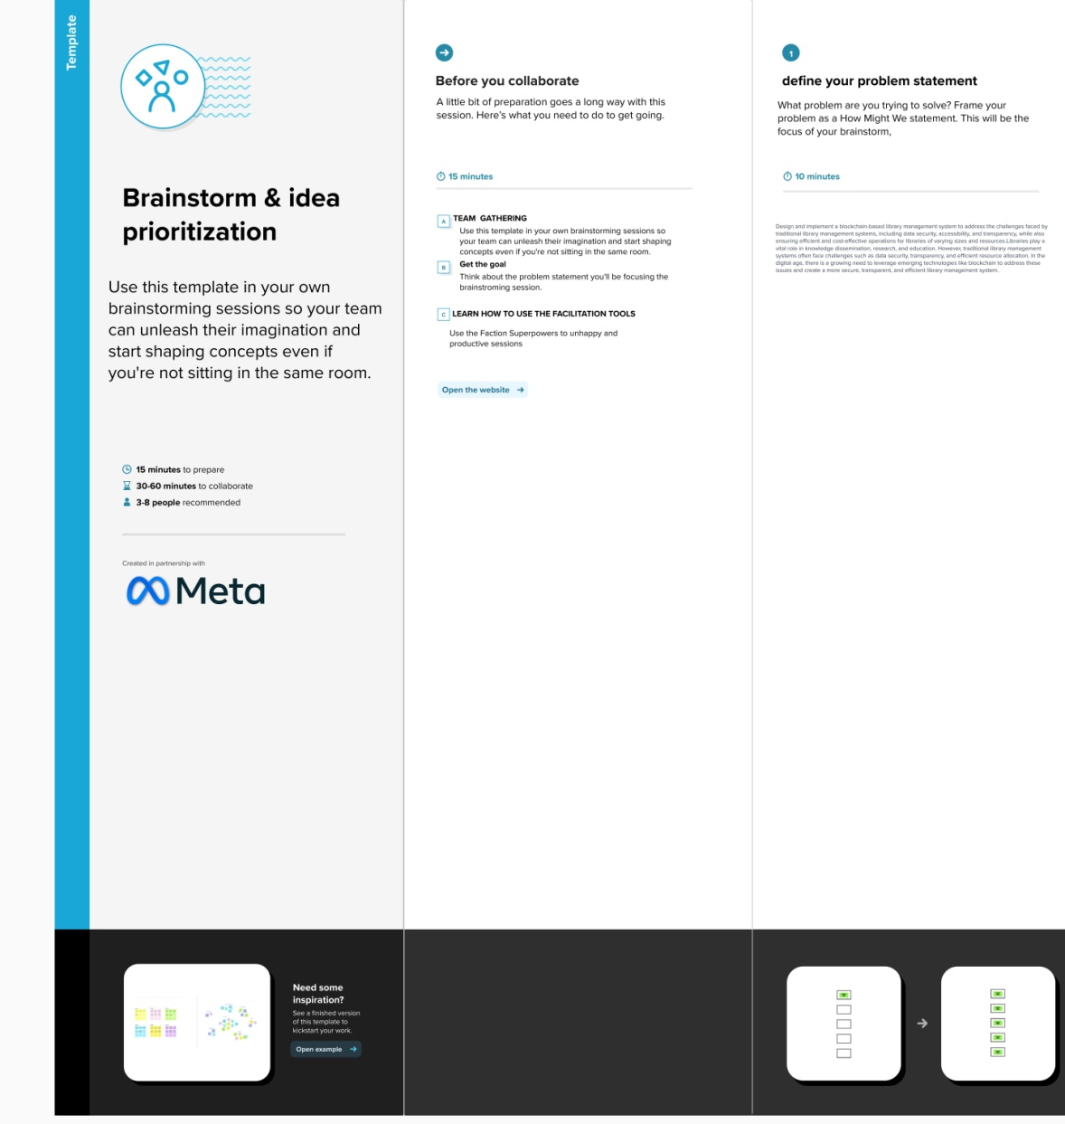

Step-2:Brainstorm,IdeaListingandGrouping

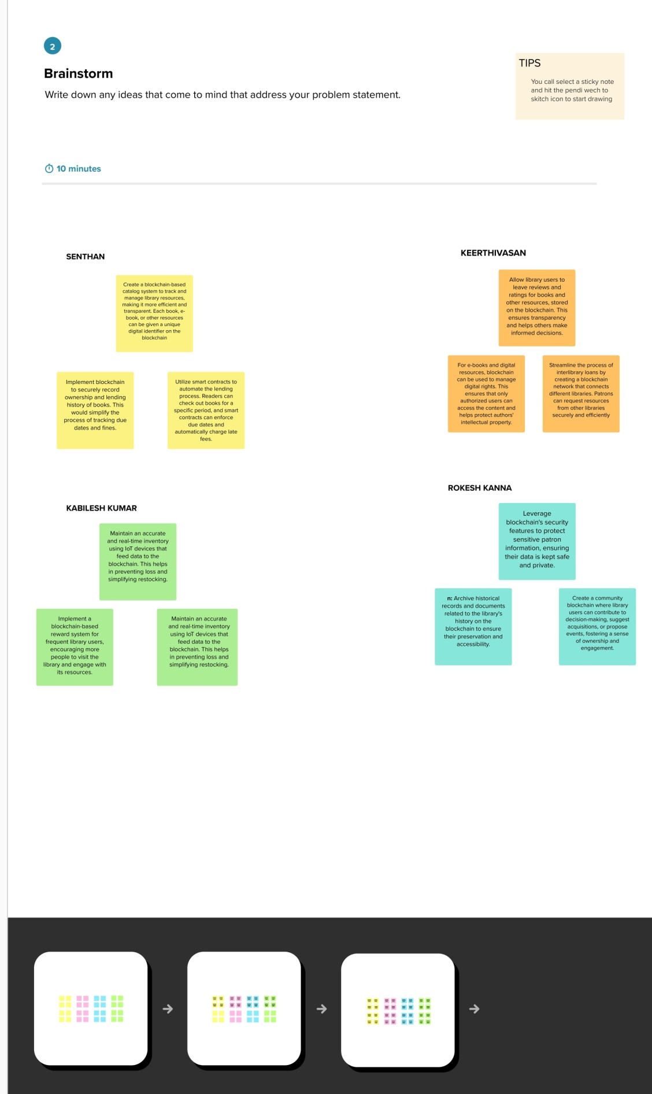

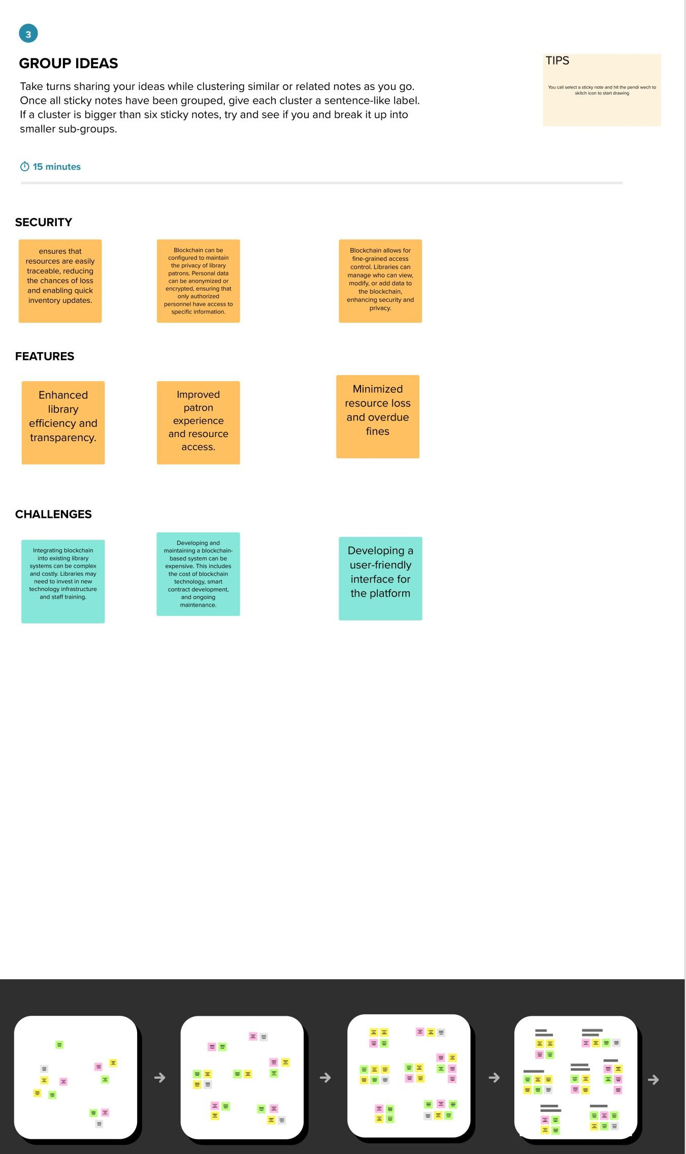

Step-3:IdeaPrioritization

